Homework 9

Continuing with GMT, AWK, and shell scripting.

In this exercise we will be making a map with earthquakes and focal mechanisms. Download the HW9.zip file from the class web page and unzip it. This should create a folder HW9 that has a script MyFirstMap.sh, and a few data and support files.

The script is below. I will be both asking questions (answer them in line and send it back to me by Tue as a WORD file so I can easily type in my comments when I grade it (I can’t do that easily with a PDF). The shell script is in blue. I will put questions in black and comments/explanations in green.

The first thing you should do after unzipping the folder is run the script MyFirstMap.sh and view the output file MyFirstMap.sh.ps. It should work (all the necessary files are contained in HW9)

My default gmt units for my laptop seems to be inches. On my mac it makes a full page sized map. I moved the HW9 directory to the mac lab (by SSHing to enigma and then SSHing to ceriml28 – you can do this – and then SFTPing the file from enigma where I had previously put it by SFTP from home – you cannot do this with stuff in my directory tree). I ran the shell script on ceriml28 and sent the file back to my home and it prints out, but it was in cm (so was ~2.5 times smaller). Setting the units did not seem to fix it, so the solution is to multiply all the numbers that are related to scale and absolute measurements (such as the offsets) by 2.54.

SmalleyMacBookPro15:-bash:HW9:505 $ cat MyFirstMap.sh

#!/bin/sh

OUTFILE=$0.ps

What is the value of $0 when this shell script starts running?

\rm $OUTFILE

touch $OUTFILE

The following sets up a number of environment variables. Notice that some of them – such as REGION – contain previously defined environment variables.

LONMIN=-90.5

LONMAX=-89

LATMIN=35.5

LATMAX=37

REGION=-R$LONMIN/$LONMAX/$LATMIN/$LATMAX

What would I get if I enter these 5 lines followed by this command “echo $REGION”?

PROJ=-Jm

SCALE=4 <-need to multiply by 2.54 if map is tiny

GRID=a1f0.5g1

B=-B$GRID

XOFF=-X1 <-need to multiply by 2.54 if map is tiny

YOFF=-Y2 <-need to multiply by 2.54 if map is tiny

The first of the next two lines expands to nothing when you put $ORIENT into a command, while the second expands to “-P”. I can set what I want here and don’t have to worry about it being empty when it is used.

ORIENT=

ORIENT=-P

NOSHOWPAGE=-K

NOHEADER=-O

CONTINUE="$NOSHOWPAGE $NOHEADER"

Verbose mode – GMT puts out chatty messages about what it is doing. Useful for debugging. Un comment 2nd line to turn it off (globally) if you don’t want all the junk printed out.

VBSE=-V

#VBSE=

gmt psbasemap $REGION $PROJ$SCALE $B $XOFF $YOFF $ORIENT $NOSHOWPAGE $VBSE >> $OUTFILE

Using the man page (but not just pasting it as the answer) explain in your own words what these two lines do.

POLITICAL=-Na

RESOLUTION=-Dh

gmt pscoast -R -J $RESOLUTION $POLITICAL $CONTINUE >> $OUTFILE

EQSYM=-Sc

INVERT=-:

#deepest earthquake in my km dataset is 19+ km, scale depth by 20 to make it range from 0 to 1 for coloring (GMT_hot.cpt goes from 0=black to 1=white)

#scale magnitude by 15 to make circle sizes reasonable and sort by magnitude (is 5th column in query.csv, but 4th column in output of awk) so dont hide large events under lots of small ones. <- you have to be careful in shell scripts with quotes. If I put the apostrophe into the word don’t here the shell will grab it and do what it does when you open quotes – so it is going to mess things up.

DEPTHRESCALE=20

MAGSIZE=15

In the psxy command here, the data is provided in lat lon order, but psxy requires lon lat. $INVERT expands as “-:” which tells psxy that the data is coming in backwards (lat lon). If the “-:” feature was not available how could you solve the problem in the awk command below of the input file having the data in the wrong order?

gmt psxy $REGION $PROJ$SCALE $EQSYM -W0.5,black -Gred -h1 -CGMT_hot $INVERT $CONTINUE $VBSE <<END>> $OUTFILE

`awk 'BEGIN {FS=","} {print $2, $3, $4/'$DEPTHRESCALE', $5/'$MAGSIZE'}' query.csv | sort -n -k4`

END

Advanced shell/awk use. The set of single quotes (strong) opening in front of the BEGIN and ending after the “}” are not required by awk, they are used to protect everything inside from processing by the shell – everything is taken literally. If I want to pass some information into awk – the scaling values in the environment variables DEPTHRESCALE and MAGSIZE, for example, I can do this by unprotecting them using single quotes around them. This follows the rules of quotes! It is a typical UNIX solution – understanding all the subtle implications of the rules.

Read the manual and explain what the extra two input data do (hint – the colors and symbol sizes). What does the sort after the awk do in terms of interpreting the data?

echo plot focal mechs

MECAPRINT="0,0"

MECASIZE=0.5

MECALABEL=0

gmt psmeca $REGION $PROJ -Sd$MECASIZE/$MECALABEL/0 -Gred -L -W0.5,black $CONTINUE $VBSE << END >> $OUTFILE

`nawk '{print $1, $2, $3, $4, $5, $6, $7, $8, $9, $10, '$MECAPRINT' }' fake_nm.dat`

END

Here we again use the single quotes to pass the MECAPRINT variable into the awk command.

The way to learn how to shell script is to start with a shell script that works and modify it for what you want to do. I will send each of you a set of lats and lons to make your own map. You will have to get the earthquake and focal mechanism data from the web.

Use the links below – the first is to get the earthquakes. It will return with a file to upload.

Keep things manageable – you only need a hundred or so earthquakes and half a dozen focal mechanisms (You might have to iterate on the time window to accomplish this – start with a year and if you get to many events, use a smaller time window).

There is a slight bug in this program if you want to print it out (it displays on the screen just fine). If you want to print it you need to change the last “$CONTINUE” to “$NOHEADER” so it puts out the “close”. An easier way to do the close so it will print just add the line

echo showpage >> $OUTFILE

at the end of the shell file

<https://earthquake.usgs.gov/earthquakes/search/>

Here is a sample input (you can zoom in Preview)

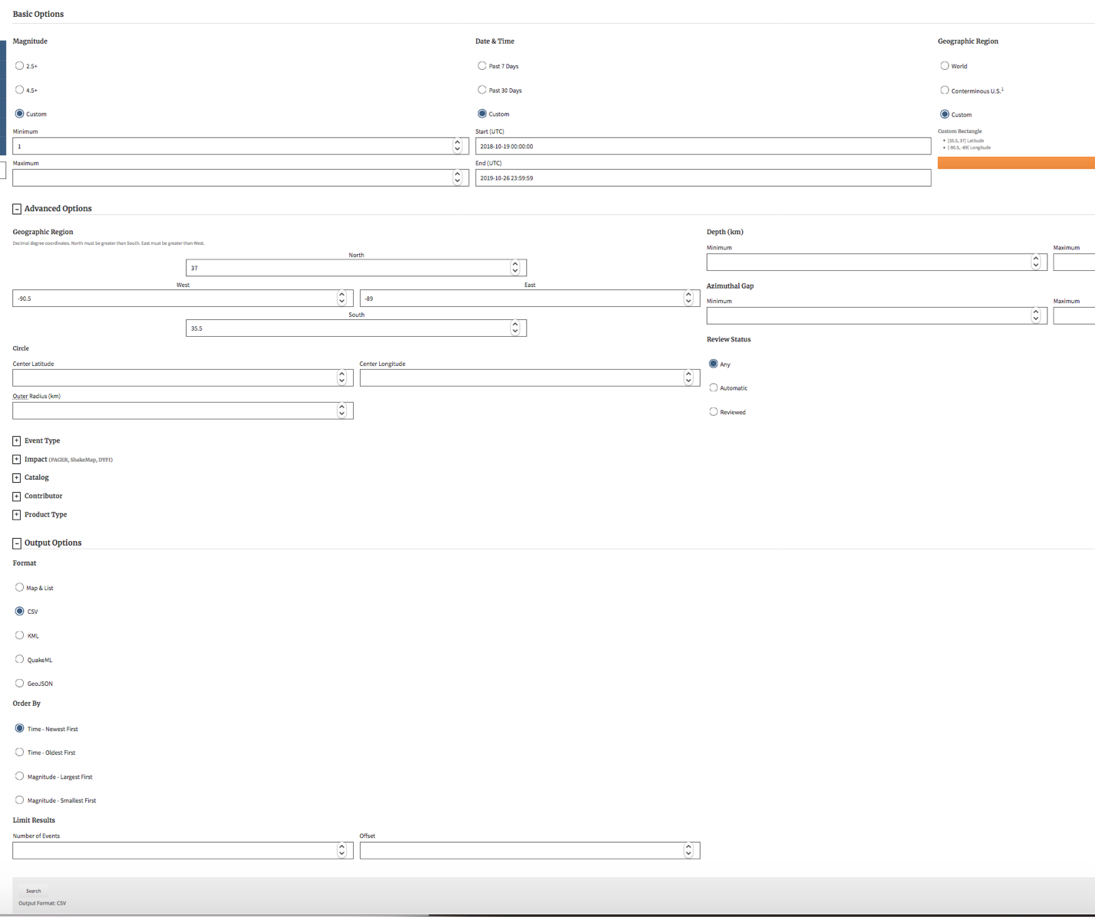

The following link is used to obtain the cmt data.

<https://www.globalcmt.org/CMTsearch.html>

Here is what the search input page looks like

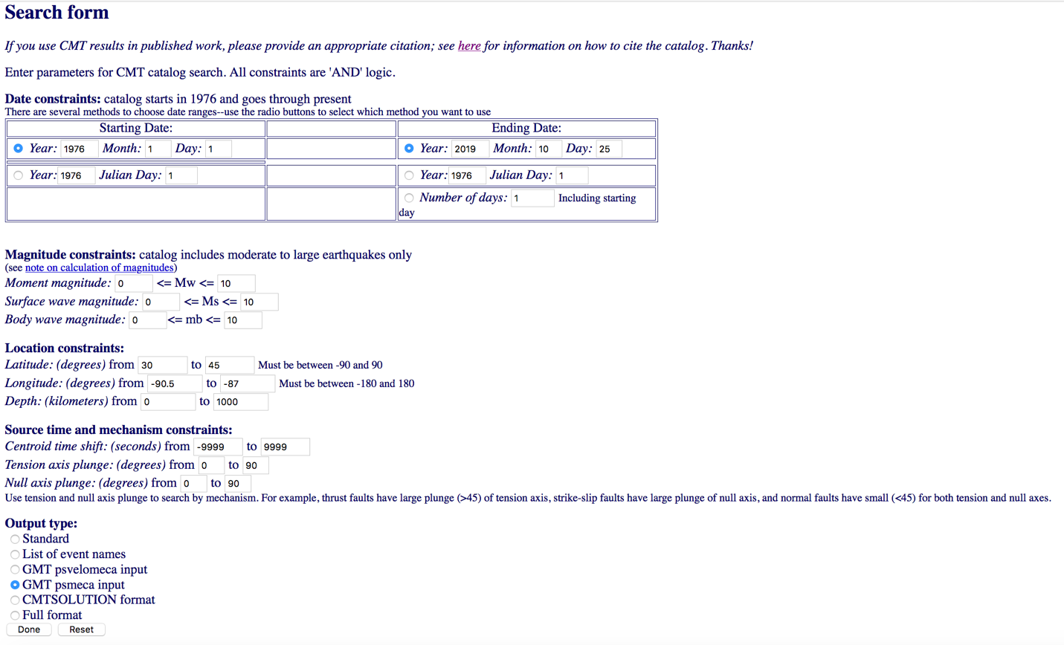

When you click on done it will open a new page that will have the results (I’m not aware of an way to get a file back)

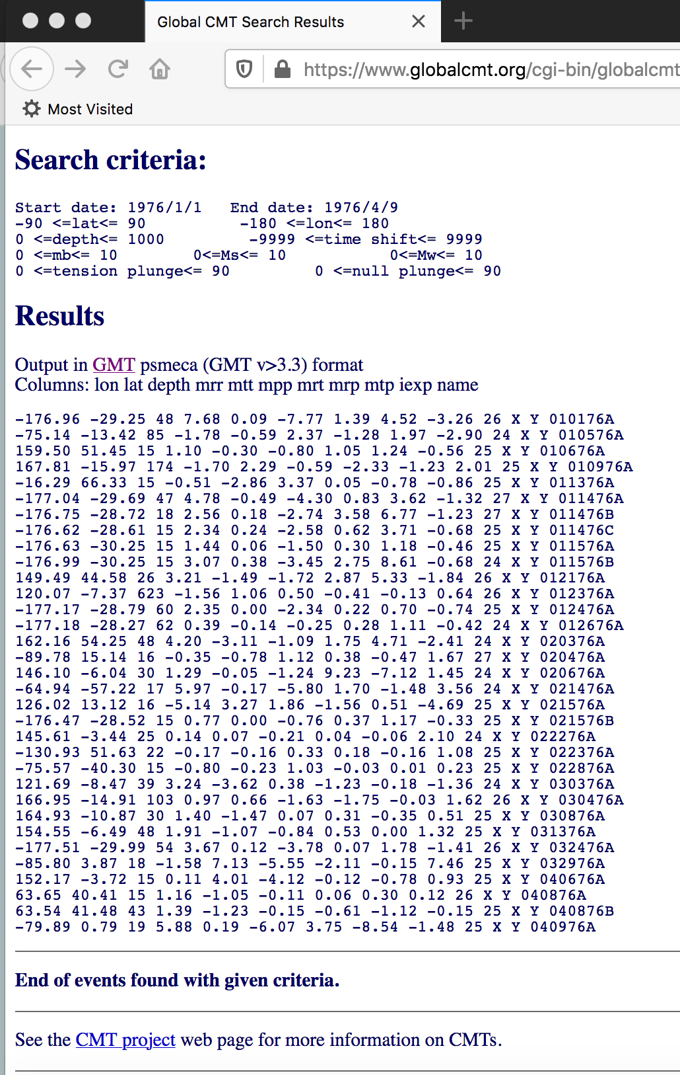

Unfortunately, you will have to copy the data and paste it into a file.

Here are the regions for your maps - each person has a different region - you should only have to look for the past 30-60 days to get enough data to plot.

You can look at the last 30 day earthquake activity by downloading the 30 day M>2.5 kml file from  the USGS at this link

https://earthquake.usgs.gov/earthquakes/feed/v1.0/kml.php

or using the attached google earth file.

You have to

1) edit the region and possibly the scale (to get it to fit on a page - the map in the provided shell script is 1.5° by 1.5°, change the scale in the script by the ratio of your map size to that - e.g. to make a map 3° by 3°, a factor of 2 bigger, **divide** the scale by the same factor), and

2) get the data from the USGS NEIC Preliminary Determination of Epicenters (PDE) and

3) the Global Centroid Moment Tensor (CMT) web pages as explained in the HW.

Email me or visit my office if you have problems.

Using the google earth file, you should see little clusters of earthquakes during the last 30 days in your area (you may have to go back longer to get the desired 100 or so earthquakes and 6-12 cmts, you can search for a longer period, and have the output sent you you sorted by magnitude, and then just take the 100 biggest ones, etc. for the cmt focal mechanisms). It is less important to get a bunch of cmts, if you don't find at least 1 cmt let me know and I'll find another region.

Some of these regions are so small you will not see anything (coastlines or political boudaries) on the base map.

Samia:  -150.4≤lon≤-148.2 and 55.9≤lat≤56.76

Kiran: -68.0≤lon≤-65.5 and -24.8≤lat≤-22.0

Dennis: -72.4≤lon≤-73.9 and -35.6≤lat≤-35.4

Marzieh: -56.6≤lon≤-55.6 and -57.4≤lat≤-55.6

Roshan: 128.9≤lon≤131.6 and -7.7≤lat≤-5.5

Anuradha: 138.0≤lon≤138.6 and -3.2≤lat≤-2.5

Kaushik: -172.9≤lon≤-171.6 and -19.0≤lat≤-18.25

Moshen: 124.9≤lon≤-125.1 and 6.55≤lat≤6.85

You will probably have to open the TIME WINDOW in the search for the CMTs. I selected the regions based on looking for earthquake clusters in the last 30 days, so the USGS NEIC PDE search should produce a bunch of earthquakes (if not open the time window).

Also - to get the lat lon selection boxes shown in the screen shot in the USGS NEIC PDE search in the word file you have to click on the "advanced" tab in the middle of the page (this will also change the region selection to "custom" automatically - you will see the numbers you type in show up there)

I checked that there was at least 1 M>5 earthquake to ensure there were some focal mechanism/cmt results, but it seems the cmt has a delay and you may not see anything in just the last 30 days (the PDE is almost immediate - less than an hour delay). Look over the last few years in the cmt search and just take a few of the newest ones (they come out in date order, newest at the end).

Any issues - come see me or send an email.

Samia also knows how to do both things above.