lCERI-7104/CIVL-8126 Data Analysis in Geophysics 2019

HW 3 – Due Sept 17

1) Plotting an XY plot on a curve.

Plot a circle 4 units in diameter and then plot sin(theta), where 0≤theta≤10*360 (10 cycles), using the large circle as the x axis. Draw locally “vertical” (“normal”, perpendicular) bars from the x-axis (the circle) to the sin curve to illustrate how such a plot is made. The plot should look like this

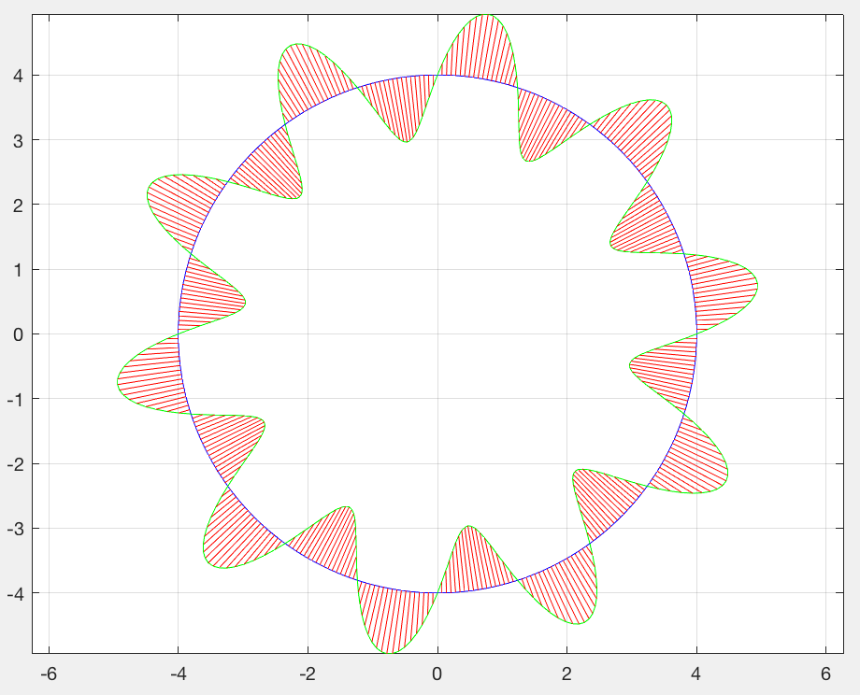

Due to the properties of the circle, the algorithm is simple, but it may not be immediately obvious. The key to how to do the plot is generalizable to (almost) any curve being used for the x-axis.

Counting the plotting commands, this takes about a dozen lines of code.

One it is working, turn it into a function that takes the radius of the large circle used as the x-axis and the number of cycles to plot as input.

2) Modify the square root function we developed in class to do 2 things

1) Accept negative numbers and return sqrt(abs(S))*i.

2) Use the method of guessing the starting value suggested on the web page describing the algorithm and compare how fast it converges to the method we originally used – first guess equals half the number whose square root we need (test it with a few really big numbers to get an idea of the speed up).

Use the Matlab log10 function to get the number of digits in the number and then use half the integer part of that exponent (careful when it is odd!) to generate the guess (this is overkill – you could just take half the log10 and raise 10 to that power to get the square root!).

If you want to actually program it by counting the digits it can be done this way. Send the value you want to take the square root of into the function as a character variable

x=’1234.56’;

Then call your square root routine

xsq=mysqrt(x)

Inside your square root routine, look for the decimal point in the character vector

dec_point_position=find(S==’.’);

dec_point_position will have the position of the decimal point or be empty if there was no decimal point. To test if it is empty use isempty, and set the number of digits to one less than the position of the decimal point if it exists or the length of the character vector.

Finally you will have to get a number for Matlab to calculate using Snumber=str2num(S) and continue as we did in class.